EXPERIMENT- 4
1. # Product Inventory Data
product <- c("Product A", "Product B", "Product C", "Product D", "Product E")
quantity <- c(250, 175, 300, 200, 220)

# Bar Chart
barplot(quantity,
names.arg = product,
col = "lightblue",
xlab = "Products",
ylab = "Quantity Available",
main = "Product Inventory")

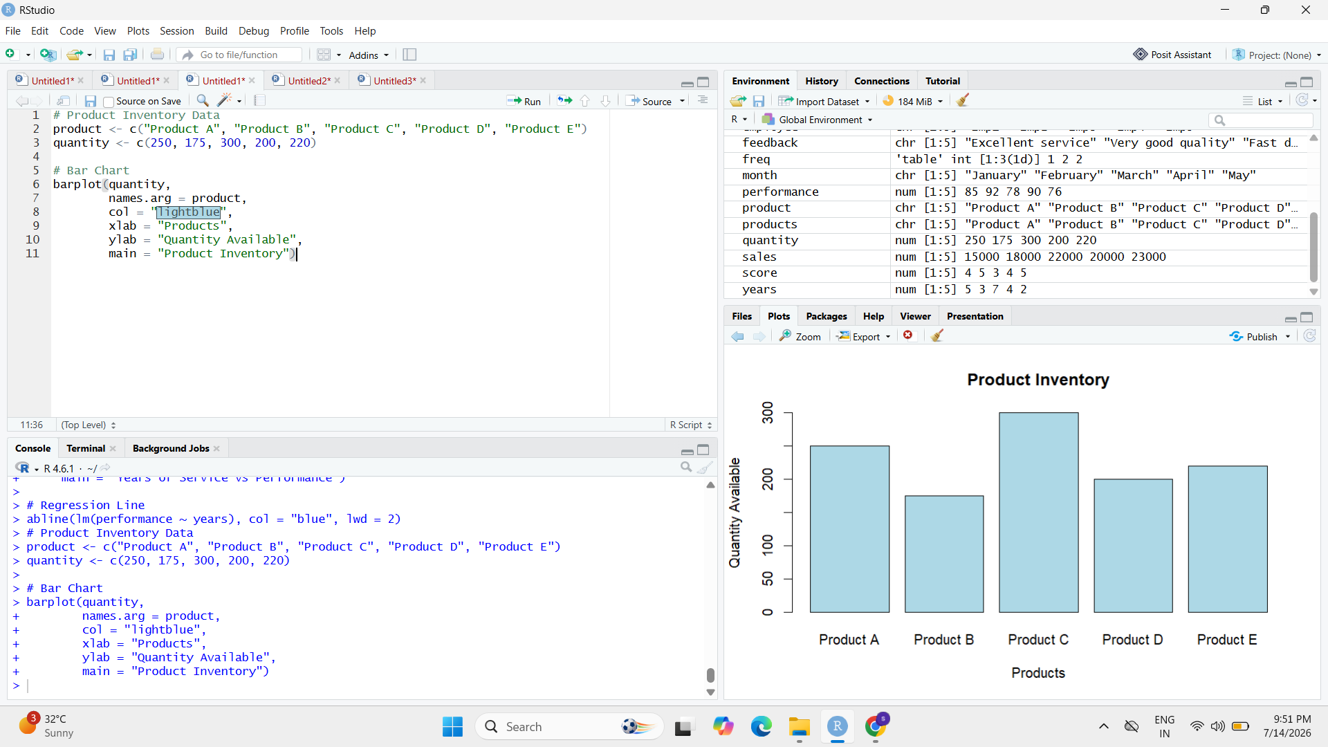

2.# Product Category Data
category <- matrix(c(
100, 80, 120,
150, 95, 180
), nrow = 2, byrow = TRUE)

colnames(category) <- c("Product A", "Product B", "Product C")
rownames(category) <- c("Category 1", "Category 2")

# Stacked Bar Chart
barplot(category,
col = c("orange", "green"),
legend = rownames(category),
xlab = "Products",
ylab = "Quantity",
main = "Quantity by Product Category")
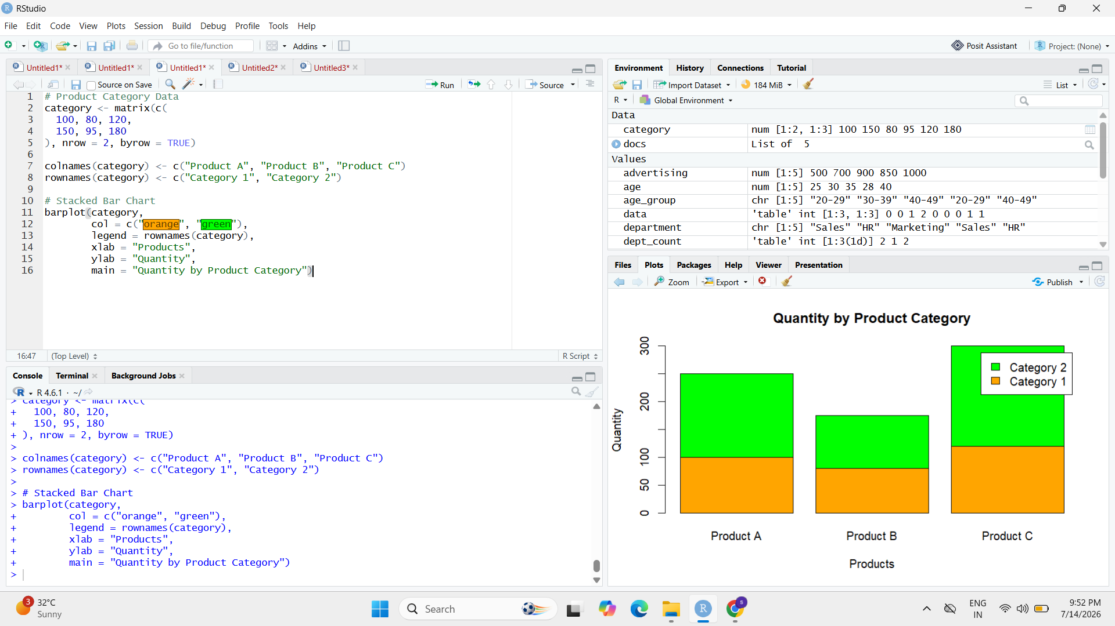
3. # Product Data
price <- c(20, 15, 18, 25, 22)
quantity <- c(250, 175, 300, 200, 220)

# Scatter Plot
plot(price,
quantity,
pch = 19,
col = "red",
xlab = "Price ($)",
ylab = "Quantity Available",
main = "Price vs Quantity Available")

# Regression Line
abline(lm(quantity ~ price),
col = "blue",
lwd = 2)
